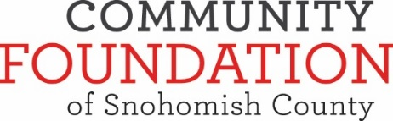

June 7, 2018

The Community Foundation of Snohomish County is a 501(c)(3) non-profit organization that serves individuals, families and area nonprofits who share a common goal: improving the quality of life in Snohomish County through informed charitable giving.

We work with donors to strengthen communities in Snohomish County by building permanent endowments, connecting donors to the charitable causes they care about, making grants, and providing collaborative leadership to address community issues.   See [www.cf-sc.org](http://www.cf-sc.org/) for further information on our organization.

We are soliciting proposals from local investment firms who are interested in providing investment management services for our endowment funds.  Currently, the pool of funds for which we are seeking proposals is in excess of $20 million and is growing rapidly as a result of increased contributions.  We currently utilize three investment managers and may replace or consolidate any of them as a result of our current due diligence. We are willing to consider one, two or three different advisors.  During the month of August 2018 we will be issuing an RFP to local investment managers interested in managing our funds.  In order to be eligible to respond to this RFP, firms must meet the following requirements:

* The managing firm must abide by the fiduciary standard of care, have at least five years of experience, and at least $200 million under management;
* The individual managing the portfolio must have a minimum of five years’ experience as an investment manager;
* Describe your team’s experience working with non-profit organizations, managing non-profit funds, and your presence in Snohomish County;
* Provide all current form ADV Part 2 or Advisory Services Brochure for your firm and related entities and programs under SEC Rule 204-3 as well as the last Annual Compliance Review as required under Rule 206(4)-7 of the Investment Advisers Act of 1940;
* Please confirm that you can report quarterly on the assets under management and that you are able to attend quarterly meetings in person;
* Provide a fee schedule for asset breakpoints of $5/$10/$20 million.

If your firm meets these requirements and would like to apply, please mail or drop off **10 copies** of the requested information **no later than 12pm on July 9, 2018 to the Community Foundation of Snohomish County, 2823 Rockefeller, Everett, WA 98201**.  Upon review of your materials, we will inform you of your inclusion in this RFP.

Sincerely,

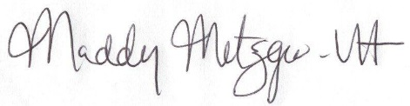

Maddy Metzger-Utt

President & CEO

*Looking Forward. Giving Back.*2823 Rockefeller Avenue, Everett, WA 98201

Phone: (425) 212-405

[elena@cf-sc.org](mailto:elena@cf-sc.org)

[www.cf-sc.org](http://www.cf-sc.org)